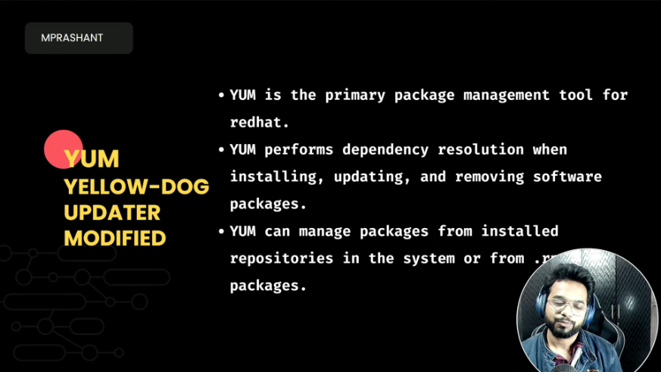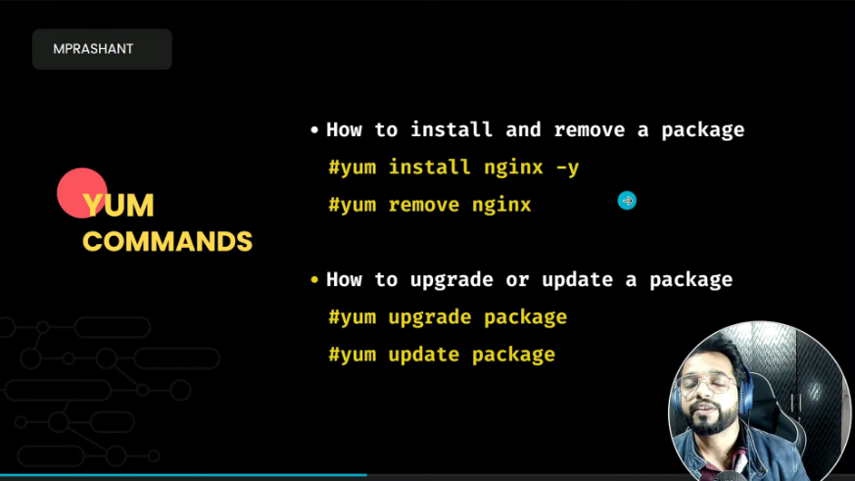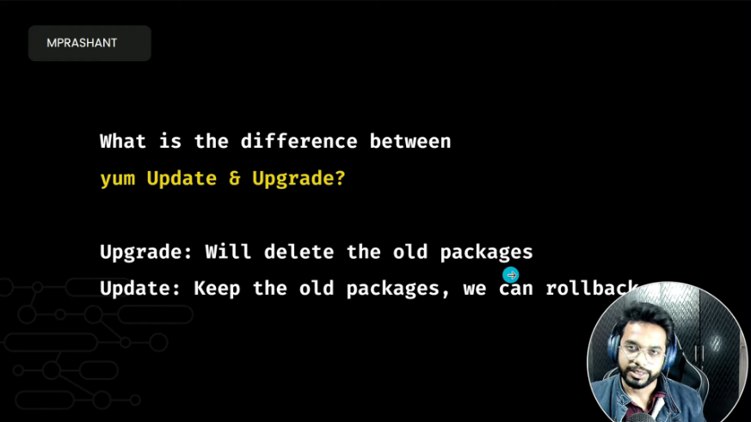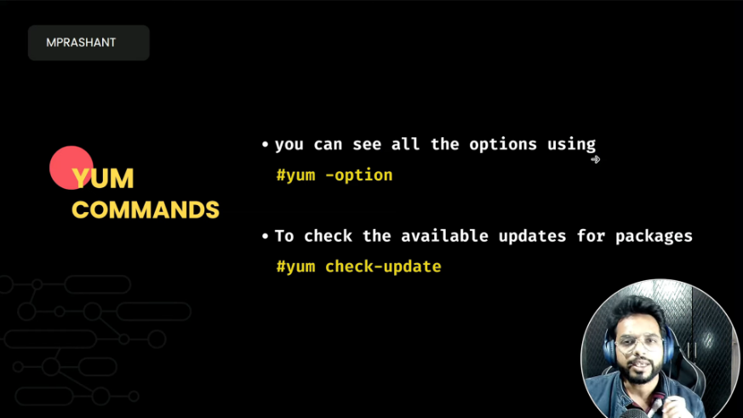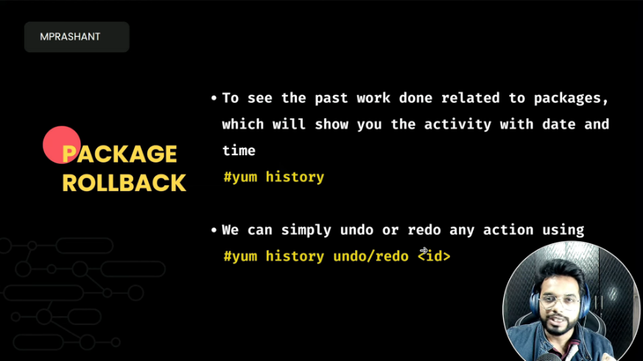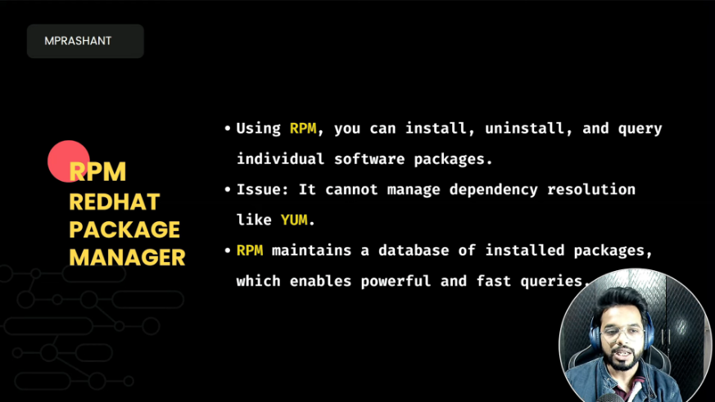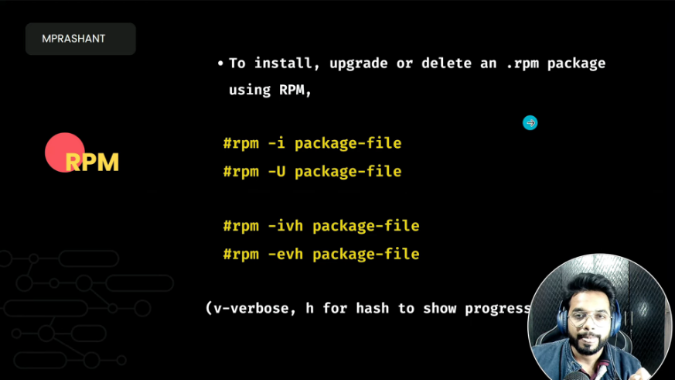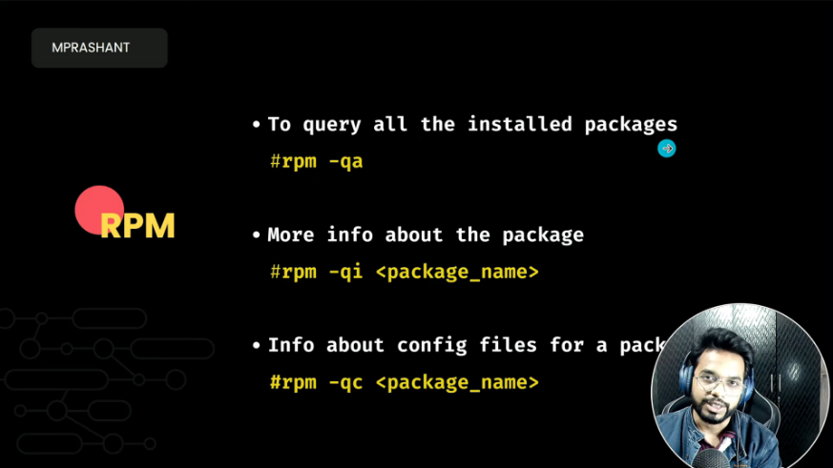

.rpm

**Scheduling Tasks using Cron**

**cron**  allows you to schedule tasks (i.e. commands or shell scripts) to run on a periodic basis. Cron checks every minute the **/var/spool/cron** directory for files which are named after accounts in **/etc/passwd**.

Crontab files (which are created by typing **crontab -e**and pressing **Enter**) have the following format:

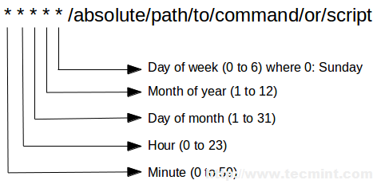

the current user’s crontab can be displayed either using cat **/var/spool/cron/root** or,

# crontab -l

### Locating and Checking Logs

System logs are located (and rotated) inside the **/var/log** directory.